GIS Topographic Wetness Index (TWI) Exercise Steps

October 2016

Jeffrey L. Zimmerman, Jr.
GIS Analyst

James P. Shallenberger
Manager, Monitoring & Protection

Susquehanna River Basin Commission

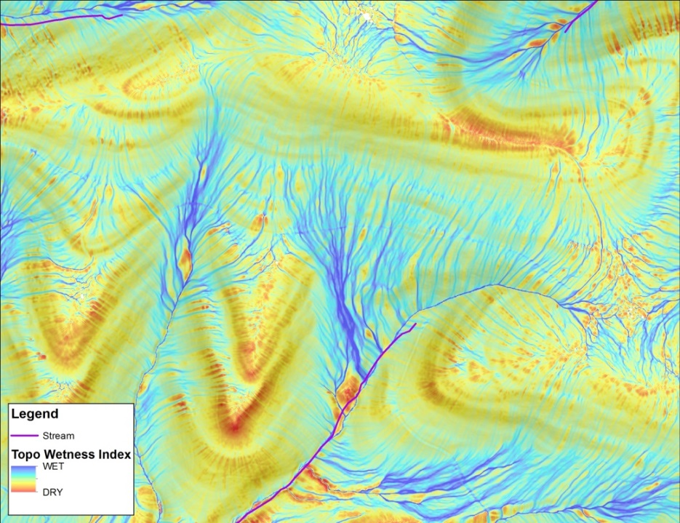

Table of Contents
INTRODUCTION 1
ACKNOWLEDGEMENT 2
A. Download LiDAR LAS Data from PASDA Website 3
B. Convert the LAS Data to a Digital Elevation Model (DEM) 4
C. Use TauDEM Extension to Generate D-Infinity Slope and Contributing Area 10
D. Calculate the Topographic Wetness Index (TWI) 13
REFERENCES 14

INTRODUCTION

This work flow process was partially supported through generous funding provided by the National Fish and Wildlife Foundation’s (NFWF’s) Chesapeake Bay Stewardship Fund (Grant No. 0603.14.045237/Marcellus Shale Sediment Control Project: 2014 – 2017).

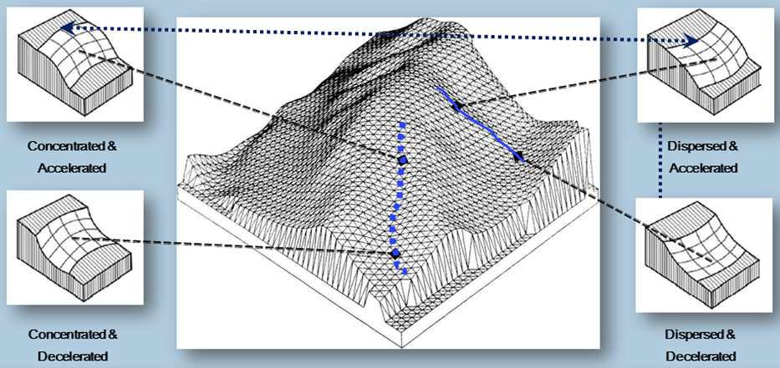
Schematic Diagram of Morphology Types Used to Compile Topographic Wetness Index

The process described herein uses a type of digital terrain analysis (DTA) resulting in a Topographic Wetness Index (TWI) that quantifies topographic controls of basic hydrological processes (Schillaci et al., 2015). TWI is derived through interactions of fine-scale landform coupled to the up-gradient contributing land surface area according to the following relationship (Beven et al., 1979):

TWI = ln [CA/Slope]

where; CA is the local upslope catchment area that drains through a grid cell and Slope is the steepest outward slope for each grid cell measured as drop/distance, i.e., tan of the slope angle (Tarboton, 1997).

Upon completion, TWI raw output is displayed as a dimensionless linear color gradient, with starting and ending point colors based on the minimum and maximum flowpath intensities unique to each catchment. Part of the NFWF study included evaluation of TWI qualitative as well as quantitative field trial verification. Repeated field trial visual assessments of hydrologic indicators, in-situ soil moisture measurements, and laboratory soil moisture quantification results (Khalequzzaman, unpublished) all converged to identify the color gradient equivalent numeric value of “11” as the reliable threshold for TWI that is consistent with preferential storm flowpaths. The color-equivalent value “11” also equated to the 99th percentile (P99) flowpath intensity of TWI output.

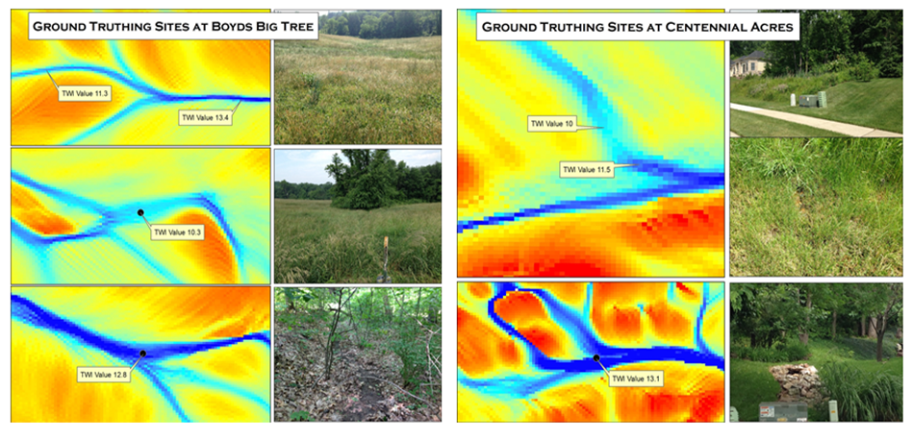
Examples of Paired TWI Model Output and Field Trial Site Photographs

TWI was applied in the Marcellus Shale Sediment Control Project as a probability-based surrogate for preferential flowpaths during storm events, although TWI offers the utility to serve a broad array of purposes.

ACKNOWLEDGEMENT

This procedure was adapted from the methodology(s) described by Cody M. Fink in Chapter 4 of his thesis entitled Dynamic Soil Property Change in Response to Natural Gas Development in Pennsylvania.

Fink, Cody M. 2013. Dynamic Soil Property Change in Response to Natural Gas Development in Pennsylvania. Pennsylvania State University, College of Agricultural Sciences. University Park, Pennsylvania.

A. Download LiDAR LAS Data from PASDA Website

- Download the “PAMAP Program – Tile Index North/South” shapefiles here: http://www.pasda.psu.edu/uci/DataSummary.aspx?dataset=266 or http://www.pasda.psu.edu/uci/DataSummary.aspx?dataset=267
- Unzip the Tile Index shapefile
- In ArcMap, overlay the Tile Index shapefile on a study area to determine necessary LiDAR LAS datasets
- Navigate to the PASDA homepage at http://www.pasda.psu.edu/
- Click the LiDAR & Elevation Data Shortcut

- Click the “PAMAP Program – LiDAR LAS files” link

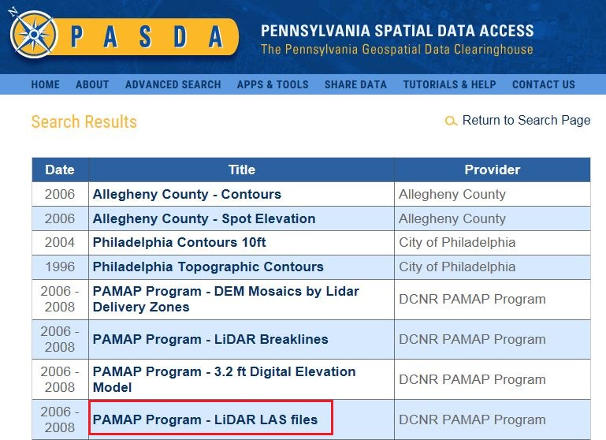

- On the PASDA PAMAP Program - LiDAR LAS files Data Summary web page, click on the “Download” link

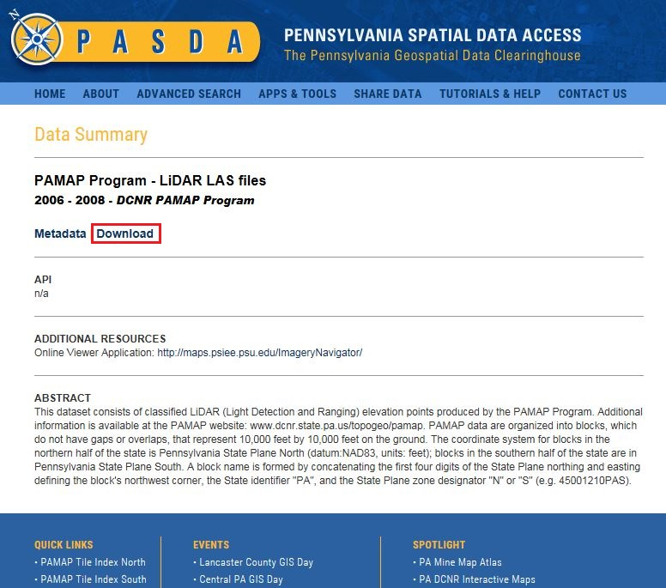

- On the FTP directory web page, click the “LAS” directory link
- On the next FTP directory web page, click either the “North” or “South” directory link
- Navigate to the appropriate FTP directories to download the necessary LAS datasets
- Unzip the LAS datasets

B. Convert the LAS Data to a Digital Elevation Model (DEM)

- In ArcMap, click the Customize dropdown menu and select ‘Extensions…’
- Activate the 3D Analyst extension
- Open the ArcToolbox window
- Expand the 3D Analyst Tools toolbox
- Expand the Conversion toolset
- Expand the From File toolset
- Open the LAS to Multipoint geoprocessing tool

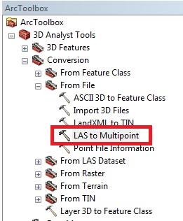

- Add all of the LAS dataset files as inputs
- Specify the output feature class
- Set the Average Point Spacing to 4.6 feet (1.4 meters)
- Add the following Input Class Codes: 2, 8, 9, 15

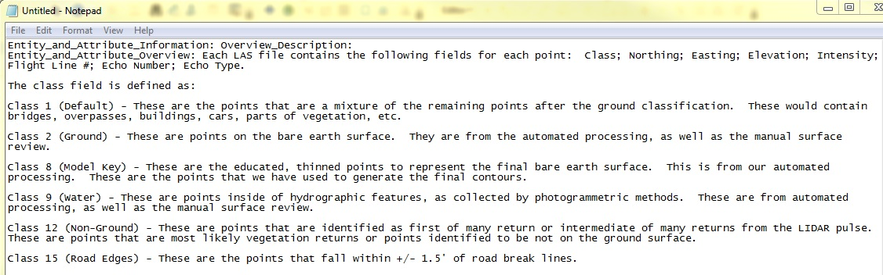

- Set the X,Y Coordinate System to Pennsylvania State Plane North (US Feet), NAD83
- Accept the default values for the remaining parameters
  - Input Return Values – Any Returns
  - Input Attribute Names – None
  - File Suffix – las
  - Z Factor – 1

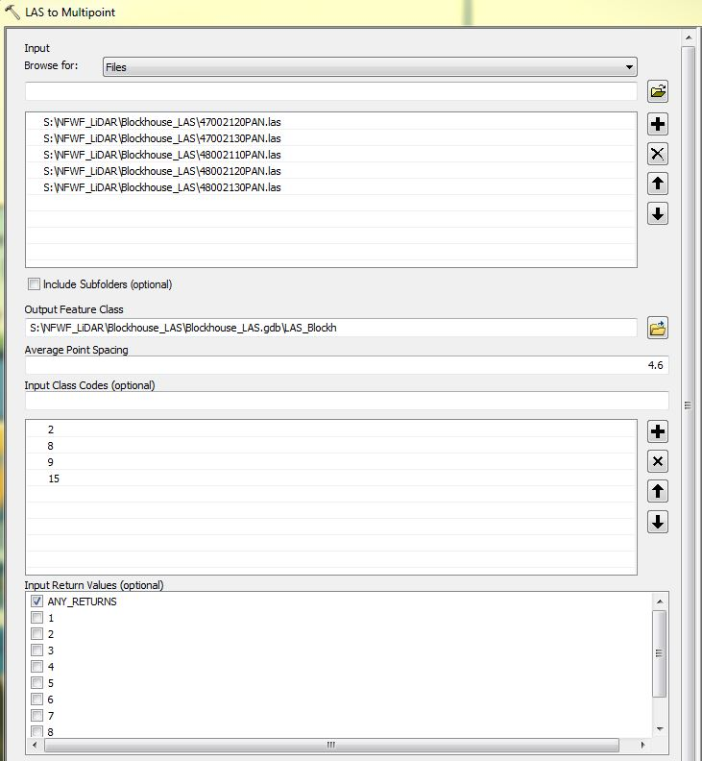
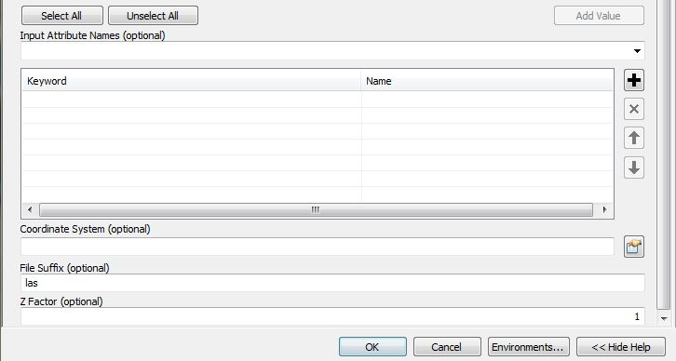

- Click OK to execute the LAS to Multipoint geoprocessing tool

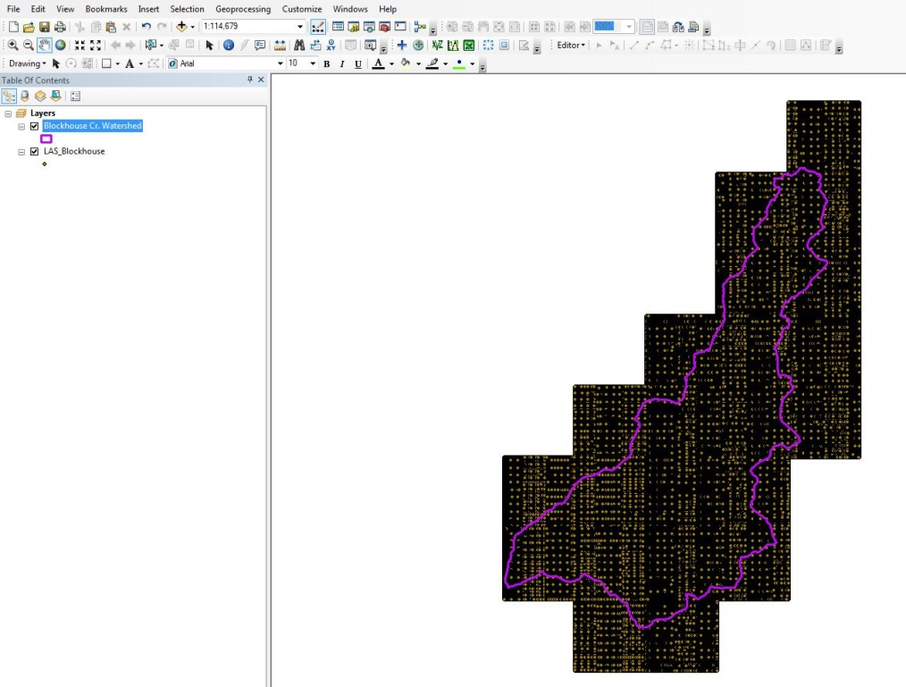

- In ArcMap, click the Customize dropdown menu and select ‘Extensions…’
- Activate the Spatial Analyst extension
- Open the ArcToolbox window
- Expand the Spatial Analyst Tools toolbox
- Expand the Interpolation toolset
- Open the IDW geoprocessing tool

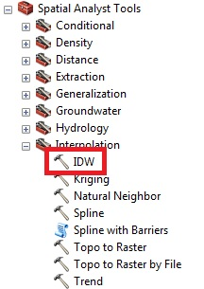

- Add the LAS multipoint feature class as the Input point features by clicking the folder icon
- Specify an Output raster with a file extension of .tif
- Select ‘Shape.Z” as the Z value field
- Set the Output cell size to 3.2
- Set the Power to 2.5
- Use a Fixed Search radius with a distance of 164 feet (50 meters) and no minimum points

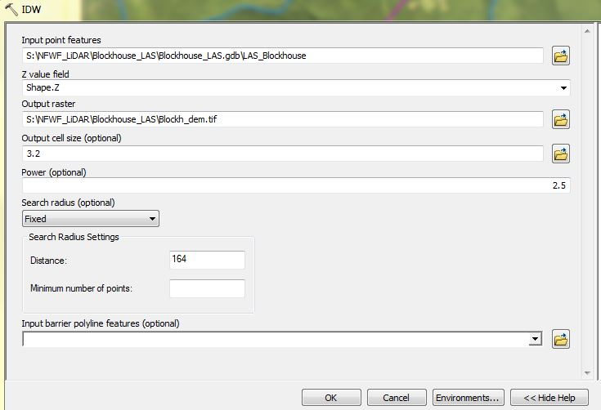

- Click OK to execute the IDW geoprocessing tool (NOTE – this may take a long time to complete depending on the size of the study area)

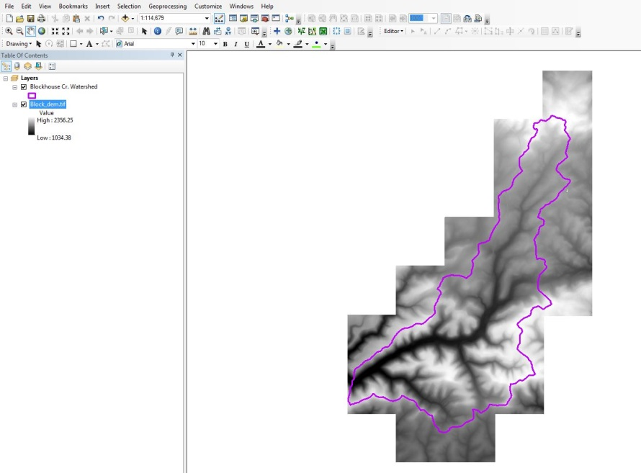

- Open the ArcToolbox window
- Expand the Spatial Analyst Tools toolbox
- Expand the Neighborhood toolset
- Open the Focal Statistics geoprocessing tool to smooth the DEM

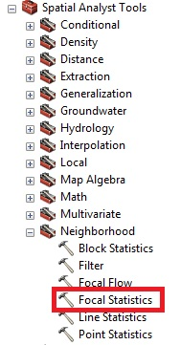

- Add the DEM as the Input Raster
- Specify an Output raster with a file extension of .tif
- Choose a Circle for the Neighborhood with a radius of 13.12 feet (4 meters) in map units
- Select MEAN for the Statistics type

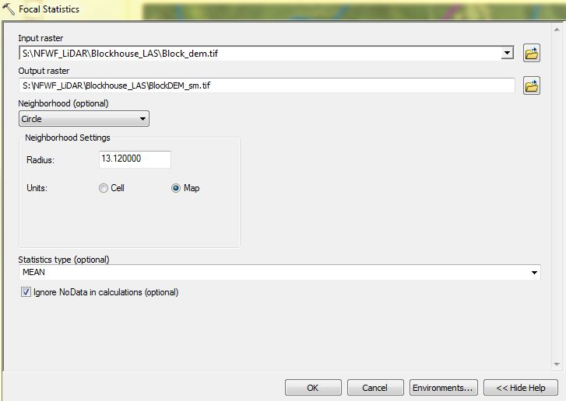

- Click OK to execute the Focal Statistics geoprocessing tool
- Save and close ArcMap

C. Use TauDEM Extension to Generate D-Infinity Slope and Contributing Area

- Open a web browser and navigate to the Utah State University TauDEM Version 5 download web page at http://hydrology.usu.edu/taudem/taudem5/downloads5.0.html
- Download the appropriate TauDEM Install Package

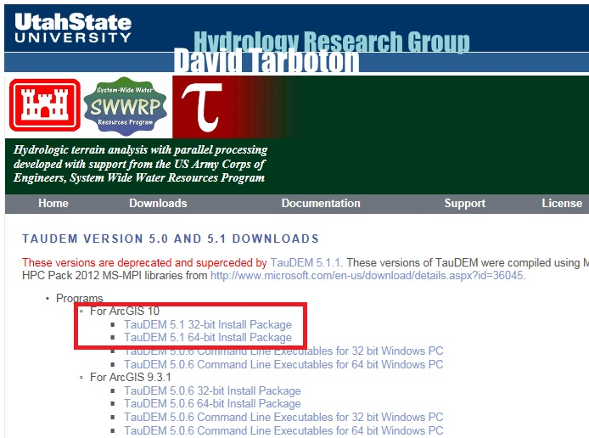

- Install the TauDEM extension and any necessary prerequisite software
- In ArcMap, open ArcToolbox
- Right-click the ArcToolbox folder at the top of the window and select ‘Add Toolbox’
- Navigate to C:\Program Files\TauDEM\TauDEM5Arc and select ‘TauDEM Tools.tbx
- Expand the TauDEM Tools toolbox
- Expand the Basic Grid Analysis toolset
- Open the Pit Remove script to remove sinks in the smoothed DEM

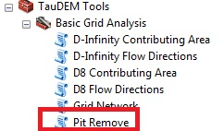

- Add the smoothed DEM as the Input Elevation Grid
- Use the default (8) Input Number of Processes
- Specify an Output Pit Removed Elevation Grid with a file extension of .tif

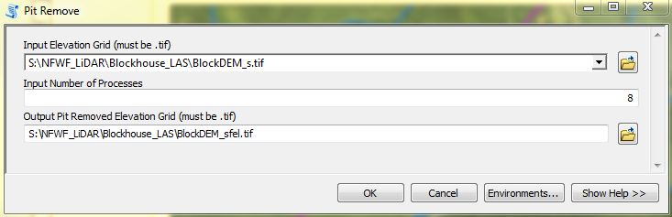

- Click OK to execute the Pit Remove script
- In ArcToolbox, TauDEM Tools toolbox, Basic Grid Analysis toolset, open the D-Infinity Flow Directions script
- Add the Pit Removed Elevation Grid as the Input
- Use the default (8) Input Number of Processes
- Specify an Output D-Infinity Flow Direction Grid with a file extension of .tif
- Specify an Output D-Infinity Slope Grid with a file extension of .tif

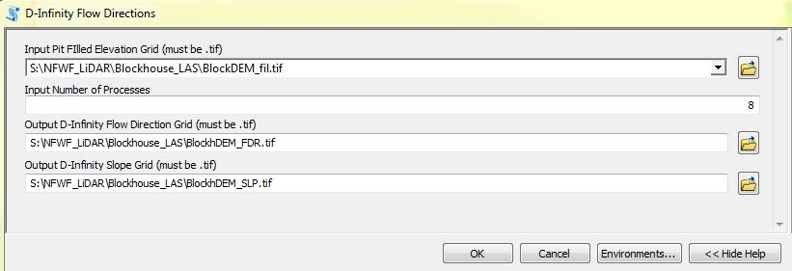

- Click OK to execute the D-Infinity Flow Directions script

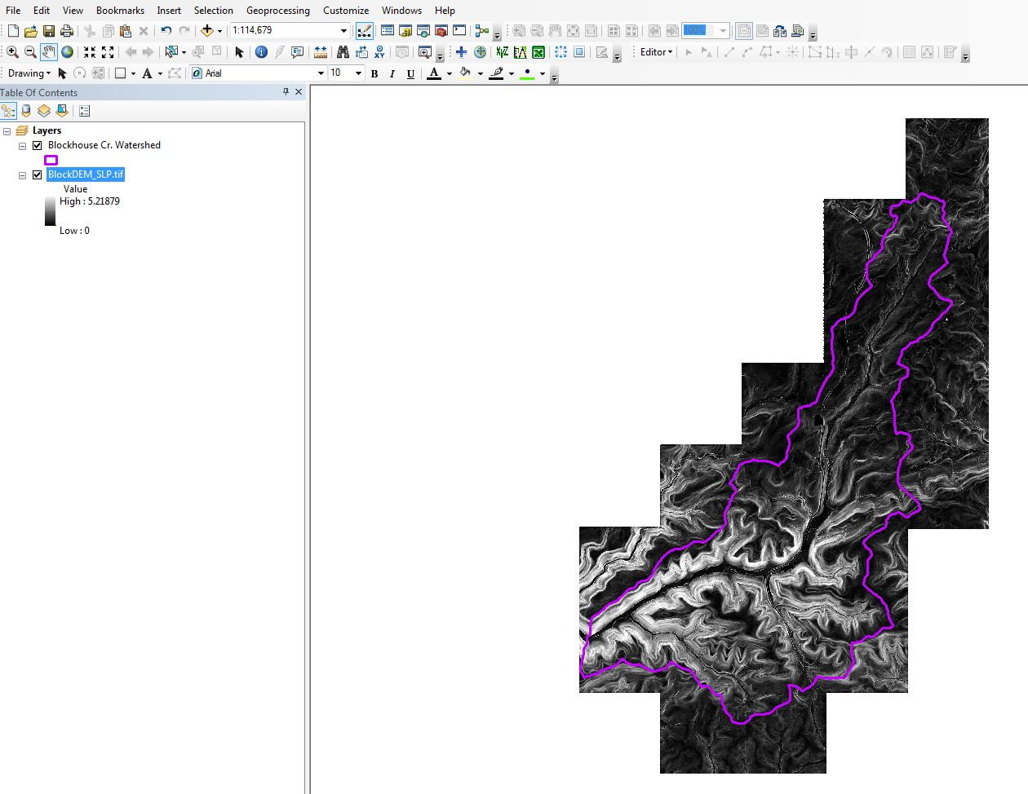

- In ArcToolbox, TauDEM Tools toolbox, Basic Grid Analysis toolset, open the D-Infinity Contributing Area script
- Add the D-Infinity Flow Direction Grid as an Input
- Use the default (8) Input Number of Processes
- Specify an Output D-Infinity Specific Catchment Area Grid with a file extension of .tif

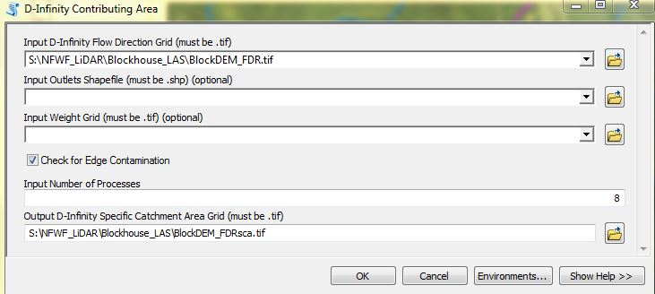

- Click OK to execute the D-Infinity Contributing Area script

D. Calculate the Topographic Wetness Index (TWI)

- In ArcToolbox, Spatial Analyst Tools toolbox, Map Algebra toolset, open the Raster Calculator geoprocessing tool
- Add the following natural logarithm (Ln) equation in the expression window: Ln(Contributing Area/Slope)
- Specify an Output TWI raster

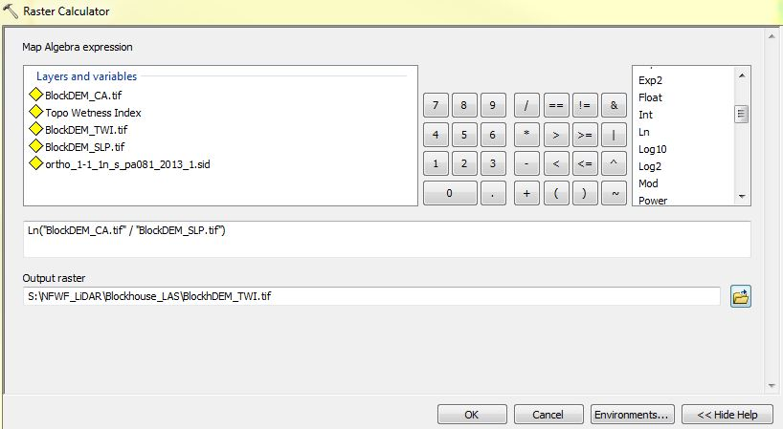

- Click OK to execute the Raster Calculator geoprocessing tool

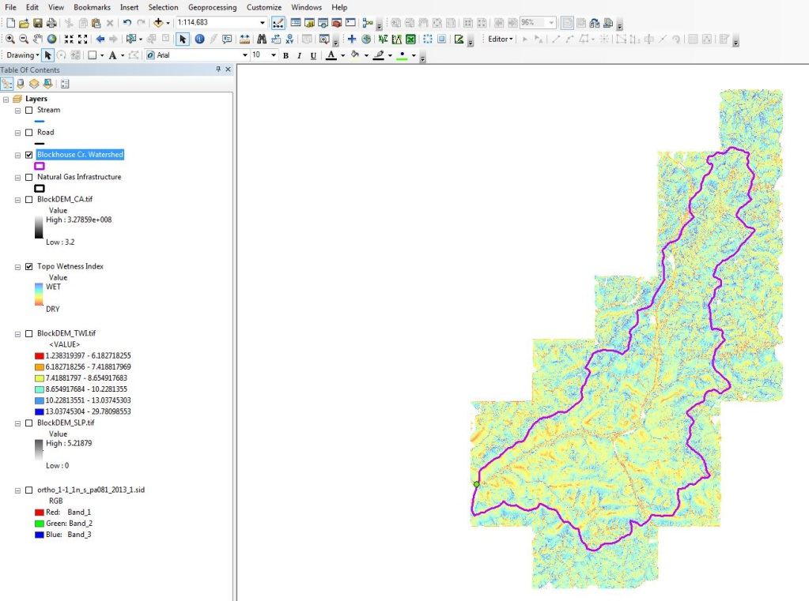

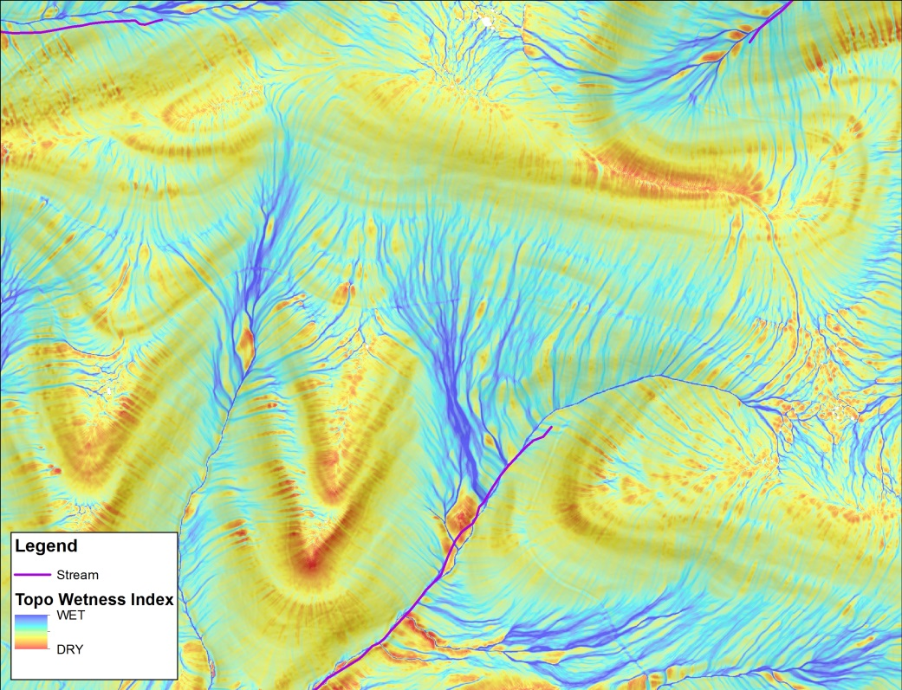

REFERENCES

Beven, K.J., M.J. Kirkby, and J. Seibert. 1979. A physically based, variable contributing area model of basin hydrology. Hydrological Science Bulletin 24: 43-69.

Schillaci, C., A. Braun, and J. Kropacek. 2015. Terrain analysis and landform recognition; Chapter 2.4.2, in Geomorphological Techniques; British Society for Geomorphology. 18 pp.

Tarboton, D.G. 1997. A New Method for the Determination of Flow Directions and Contributing Areas in Grid Digital Elevation Models. Water Resources Research, 33(2): 309-319.Steps to Generate Topographic Wetness Index (TWI) in ArcMap 10.2.2

